TailWindCSS Installation and HelloWorld Program Execution

Source Video Link: https://www.youtube.com/watch?v=SPr-1cwVn1k
Create a folder, open with vs code, use command prompt
Command Ensure node version by node -v
Command Ensure npm version by npm -v
Command Type npm init -y to create package.json file
Install TailwindCSS framework by the following command
Command npm install -D tailwindcss@3 check in package.json file
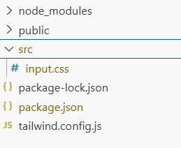 | 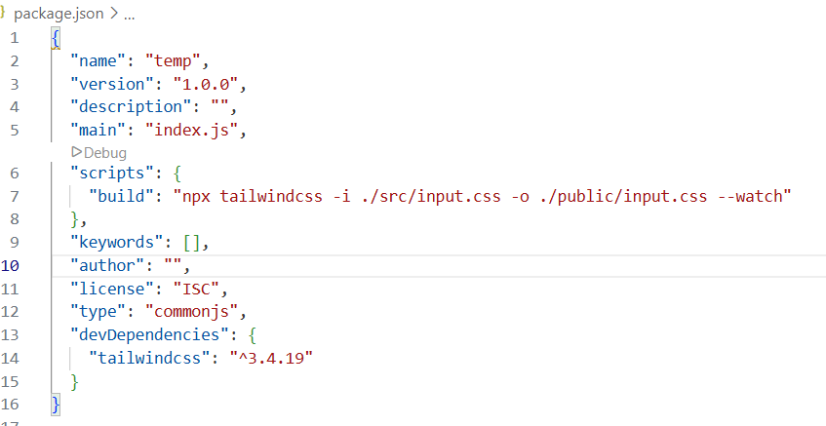

Create src and public folder
Under src, create input.css and type the following:
@tailwind base;
@tailwind components;
@tailwind utilities;

In command prompt, type the following:
Command npx tailwindcss init
This will create tailwind.config.js file. In this file modify the content as follows:
/** @type {import('tailwindcss').Config} */
module.exports = {
content: ["./public/**/*.html"],
theme: {
extend: {},
},
plugins: [],
}

Under public folder create index.html and keep the following contents:
<html>
<head>
<link rel="stylesheet" href="./input.css">
</head>
<body>
<h1 class="text-center text-red-500 p-4">Welcome</h1>
</body>
</html>

In package.json write the script
"scripts": {
"build": "npx tailwindcss -i ./src/input.css -o ./public/input.css --watch"
},
In command prompt run the command
npm run build

Goto index.html, right click – open with live server to the following output
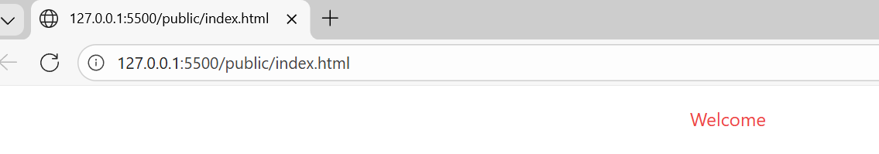
Install Extensions – Live Preview, TailWindCSS IntelliSense

How to use TailWindCSS in React
https://www.youtube.com/watch?v=L3wJe66tlBk

